**How to get versions：**

1. Connect to the USART1 port of BASEX+ using the serial port tool

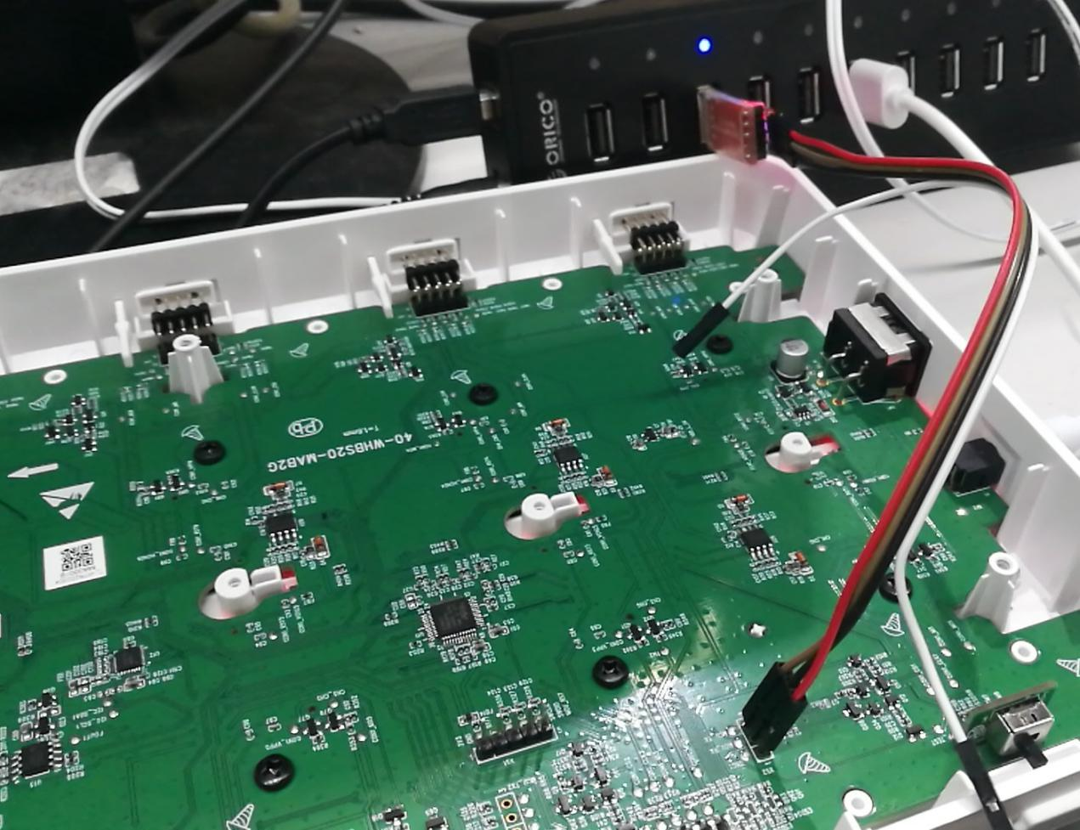

Uart1

1. Insert a card with an ADC greater than 30 into slot 1
2. When the BASEX+ user program running,Waiting for the 3 s

Then,Send USART command:

(1). Enter/exit the factory test

Send：

|  |  |  |  |  |
| --- | --- | --- | --- | --- |
| The frame header | Data len | order | data | Check sum |
| 0xFF 0x55 | 0x01 | 0x06 | Enter/exit | XX |

Return：

|  |  |  |  |  |
| --- | --- | --- | --- | --- |
| The frame header | Data len | order | data | Check sum |
| 0xFF 0x55 | 0x00 | 0x06 | 无 | XX |

Example:

Send： enter the factory test：FF 55 01 06 01 AC

(Note: 01 enter the factory test.Exit factory test at 00)

Return：FF 55 00 06 AC

(Note, after the instruction is executed, power outage is required to restart to take effect)

4.After a power outage and restart, BASEX+ will go to ATS mode,Send command:

(2).Query version

Send:

|  |  |  |  |  |
| --- | --- | --- | --- | --- |
| The frame header | Data len | order | data | Check sum |
| 0xFF 0x55 | 0x00 | 0x07 | 无 | XX |

Return：

|  |  |  |  |  |
| --- | --- | --- | --- | --- |
| The frame header | Data len | order | data | Check sum |
| 0xFF 0x55 | 0x01 | 0x07 | version | XX |

Example:

Send：FF 55 00 07 AD

Return：FF 55 01 07 01 AD

(Note, 01 is the version number)

1. Use the exit ATS command

Example:

Send： Exit factory test：FF 55 01 06 00 AD

(Note: 01 enter the factory test.Exit factory test at 00)

Return：FF 55 00 06 AC

(Note, after the instruction is executed, power outage is required to restart to take effect)

5.An example of sending

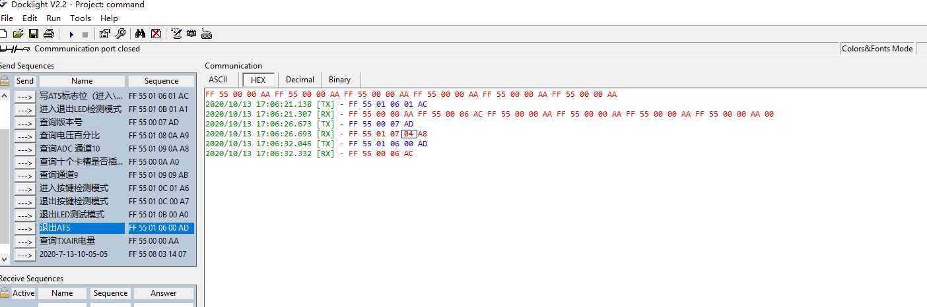

6.BASEX+ will return to user mode after another power outage and restart